Maddock Public School #9
Regular Meeting Tuesday November 7, 2023 7:00 AM
Present: Sheila Lindgren, Justin Maddock, Bryan Kenner, Bridget Geller, Paul Backstrom, Mr. Allmaras, Mrs. Hill, & Shannon Louder-Business Manager Guest- Mavis Maloney
Meeting called to order at 7:04am.
Motion made by Backstrom, seconded by Kenner to approve the agenda. Motion carried.
Motion made by Geller, seconded by Kenner to approve the consent agenda. Motion carried.

Principal Report by Mrs. Hill- 2nd grade to memorial home next week, Pre-K had pumpkin carving, Respect was the character count last month, Responsibility is for Nov, Sam Sears from NDSU Extension was in to visit classes in elementary on nutrition, & elementary conferences went well and only had 1 family not attend.

Superintendent Report by Mr. Allmaras- Boiler inspection passed 11/6/23, looking into options for student teachers, Nov 17 elementary will help with Feed my Starving Children, high school had 50% attendance for parent teachers’ conferences, 10 community members helped clean and prepare our football field in a case we could have hosted playoff game, National FFA- Maddock team got bronze, and had 44 high schoolers on honor roll.

Athletic Director Report by Shannon Sabbe- 2 elementary boys’ games this week, volleyball wrapped up this week, girls basketball begins Nov 13 with Bryan Kenner as head coach, boys begin Nov 27 with Ben Allmaras as head coach,

Motion by Backstrom, seconded by Maddock to approve a satisfactory rating on Personal/Professional Goals. Roll call in favor. Motion carried. Motion by Kenner, seconded by Geller to approve a satisfactory rating on Leadership Competencies. Roll call all in favor. Motion carried. Motion by Maddock, seconded by Kenner to approve a satisfactory rating on Executive Director Expectations. Roll call all in favor. Motion carried. Motion made by Geller, seconded by Maddock to approve a satisfactory rating on Strategic / Operational Plan Progress. Roll call all in favor. Motion carried.

Motion made by Geller, seconded by Kenner to waive second reading and approve policy ABEC- School Meal Charge Policy. Motion approved.

Discussion was held on the 2023 Annual NDSBA Convention.

Motion made by Kenner, seconded by Geller to adjourn at 8:03. Motion carried.

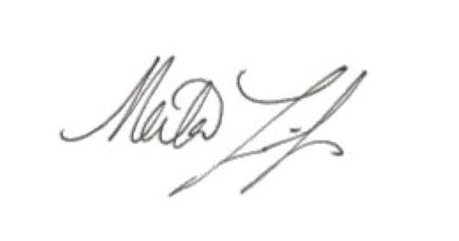
President- Sheila Lindgren

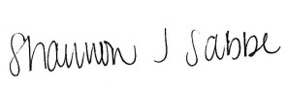
Business Manager- Shannon Sabbe

