Sunday | Monday | Tuesday | Wednesday | Thursday | Friday | Saturday
1  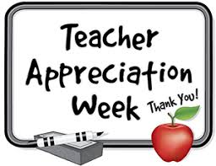  Teacher Appreciation Week | 2  Principal’s Day | 3  12:20-1:10 3rd & 4th Instrumental test day  2:00 Track @ Rugby V & JH  6:00 Academic Challenge @ Harvey | 4 | 5  3:30 Track @ Rugby  5:00 EVB @ New Rockford | 6  9:00 K-9 presentation for K-6  School Lunch Hero Day | 7  11:00 Track @ Carrington
8 | 9  5:00 EVB vs Leeds @ Maddock | 10  2:00 CNDC Track Meet @ Fessenden | 11  Play Day @ Ft. Totten  6:30 Co-op Athletic Banquet @ Maddock | 12  7 AM School Bd Mtg | 13  3:30 Track @ St. John - JH | 14  10 AM Track @ Fessenden
15 | 16  1:00 Gr 1-12 @  Maddock Airport  4:00 Track @  D. Lake | 17  7/8th Field trip Bismarck | 18  1:30 Wax Museum  Play Day alternate date | 19  K-6 Field trip  7-12 Field trip | 20  Last day of school  11:00  PICNIC  3:30 NC Region Track @ Rugby | 21
22  1:00 Graduation | 23  FFA District 3 contests @ Rugby | 24 | 25 | 26  State Track Meet Bismarck | 27  State Track Meet Bismarck | 28  State Track  Meet Bismarck
29 | 30  Memorial Day | 31  FFA CDE Workouts @ Carrington | June 1  Drivers Ed | June 2  Drivers Ed | June 3  Drivers Ed | June 4
“This institution is an equal opportunity provider”

